Earth Science Practice Ch. 19 Test

Multiple Choice
Identify the choice that best completes the statement or answers the question.

____ 1. Movement occurs along fractures in rocks when _____.
a. | stress equals the strength of the rocks involved | c. | stress is applies to the rocks involved
b. | stress overcomes the strength of the rocks involved | d. | stress is less than the rocks involved

____ 2. The strain which causes a material to twist is known as ____.
a. | stress | c. | tension
b. | compression | d. | shear

____ 3. The strain which causes a material to pull apart is known as ____.
a. | stress | c. | tension
b. | compression | d. | shear

____ 4. P-waves and S-waves are also known as ____.
a. | surface waves | c. | body waves
b. | ground waves | d. | first waves

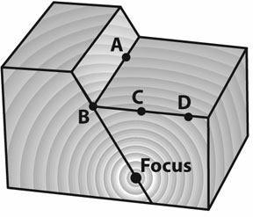

Use the diagram to answer the questions.

____ 5. Which point marks the epicenter of the earthquake?
a. | A | c. | C
b. | B | d. | D

____ 6. At which point will the most damage as a result of the earthquake occur?
a. | A | c. | C
b. | B | d. | D

____ 7. What is true about the focus?
a. | It is the point where the most surface damage will occur. | c. | It is the point where the waves are attracted.
b. | It is the point where the surface waves originate and spread out. | d. | It is the point of failure where the waves originate.

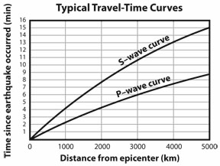

Use the graph to answer the questions.

____ 8. A seismogram is located 4500 miles away from the epicenter of an earthquake. What is the difference in time between when the P-waves reach the seismogram and the S-waves reach the seismogram?
a. | 5 1/2 minutes | c. | 10 minutes
b. | 6 minutes | d. | 22 minutes

____ 9. P-waves reaches a seismogram 6 minutes after an earthquake occurs and the S-waves arrive 3 and a half minutes later. How far is the seismogram from the earthquakes epicenter?
a. | 1000 km | c. | 3000 km
b. | 2000 km | d. | 4000 km

Location | Earthquake History | Strain Buildup Rate
A | many earthquakes | slow
B | few earthquakes | moderate
C | many earthquakes | fast
D | many earthquakes | moderate

____ 10. Organize the locations from lowest to highest hazard.
a. | B, A, D, C | c. | A, B, C, D
b. | C, D, A, B | d. | B, A, C, D

____ 11. Location D just experienced an earthquake. Which location will most likely experience the next earthquake?
a. | Location C because it has the highest hazard. | c. | It is impossible to tell because the data just gives the risks for earthquakes not a predictable forecast.
b. | Location A because it is just below location D in hazard level. | d. | It is impossible to tell because the proximity of the other locations to D is not known.

____ 12. A ____ fault forms as a result of horizontal compression.
a. | blind | c. | strike-slip
b. | normal | d. | reverse

____ 13. The San Andreas Fault, a result of horizontal shear, is a ____ fault.
a. | blind | c. | strike-slip
b. | normal | d. | reverse

____ 14. When the force on rocks is great enough, they break, producing vibrations called ____.
a. | faults | c. | strains
b. | earthquakes | d. | stresses

____ 15. Once the elastic limit of rocks is passed, they break and move along surfaces called ____.
a. | faults | c. | strains
b. | earthquakes | d. | stresses

____ 16. Scientists discovered changes in Earth's interior by studying ____.
a. | tsunamis | c. | changes in seismic waves
b. | tides | d. | all of the above

____ 17. ____ is the force that squeezes rocks together.
a. | Tension | c. | Elastic limit
b. | Shear | d. | Compression

____ 18. ____ is the force that pulls rocks apart.
a. | Tension | c. | Elastic limit
b. | Shear | d. | Compression

____ 19. ____ is the force that causes plates to move sideways past each other.
a. | Tension | c. | Elastic limit
b. | Shear | d. | Compression

____ 20. ____ faults are caused by tensional forces.
a. | Normal | c. | Reverse
b. | Strike-slip | d. | Elastic

____ 21. ____ faults are caused by compressional forces.
a. | Normal | c. | Reverse
b. | Strike-slip | d. | Elastic

____ 22. ____ faults are caused by shear forces.
a. | Normal | c. | Reverse
b. | Strike-slip | d. | Elastic

____ 23. The most destructive seismic wave are ____.
a. | primary waves | c. | P-waves
b. | secondary waves | d. | surface waves

____ 24. The ____ waves are the first to reach a seismograph after an earthquake.
a. | surface | c. | primary
b. | secondary | d. | tsunami

____ 25. At least ____ seismographs are needed to accurately locate an earthquake epicenter.
a. | two | c. | four
b. | five | d. | three

____ 26. The point in Earth's interior where the energy release of an earthquake occurs is the ____.
a. | focus | c. | fault
b. | epicenter | d. | inner core

____ 27. Primary waves ____ when they hit the liquid outer core.
a. | slow down | c. | stop
b. | stay the same | d. | speed up

____ 28. Secondary waves ____ when they hit the liquid outer core.
a. | slow down | c. | stop
b. | stay the same | d. | speed up

Completion
Complete each statement.

29. In a(n) _________________________, the fracture is caused by horizontal shear and movement is mainly horizontal.

30. A(n) ____________________ forms as a result of horizontal compression and results in a shortening of the crust involved.

31. Along a(n) ____________________, movement is both horizontal and vertical, resulting in a lengthening of the crust involved.

Matching

Match each item with the correct description below. You may use a term more than once.
a. | surface wave
b. | P-wave
c. | S-wave

____ 32. Does not pass through Earth’s liquid outer core

____ 33. Does not pass through Earth’s interior at all

____ 34. Squeezes and pulls rocks in same direction as the save travels

____ 35. Is refracted by Earth’s core

____ 36. Absence of this kind of waves results in a shadow zone

Match each description with the fault it is describing. Answers will be used more than once.
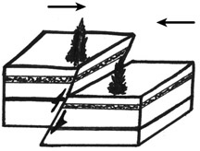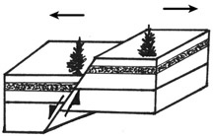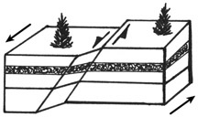

____ 37. experiences only horizontal movement

____ 38. two trees formerly side by side become closer after faulting

____ 39. the San Andreas Fault in California

____ 40. experiences tension from stretching

____ 41. seen near convergent plate boundaries

Short Answer

42. Which direction of ground movement—horizontal or vertical—is detected by the seismograph shown below, and how can you tell?

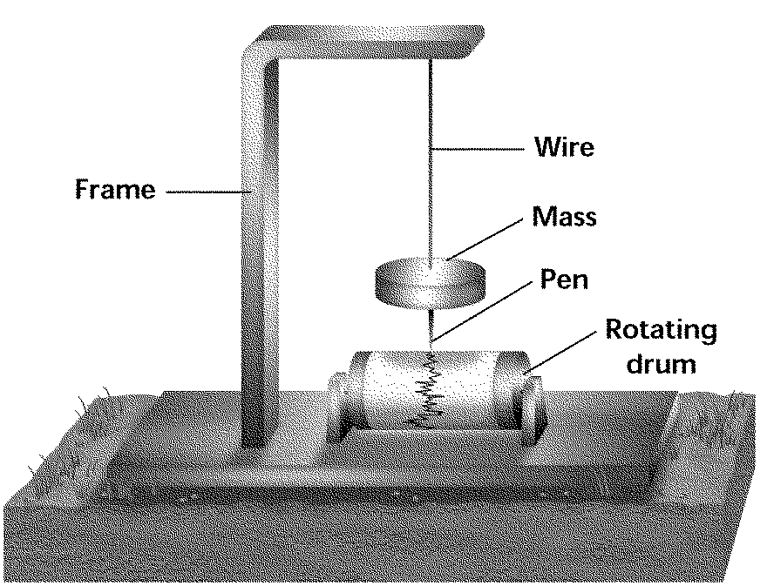
Earth Science Ch. 19 Test
Answer Section

MULTIPLE CHOICE

1. ANS: B PTS: 1 DIF: Bloom's Level 1
NAT: B.6 STA: SC.D.1.4.2

2. ANS: D PTS: 1 DIF: Bloom's Level 2
NAT: B.6 STA: SC.D.1.4.2

3. ANS: C PTS: 1 DIF: Bloom's Level 2
NAT: B.6 STA: SC.D.1.4.2

4. ANS: C PTS: 1 DIF: Bloom's Level 1
NAT: B.6 STA: SC.D.1.4.2

5. ANS: C PTS: 1 DIF: Bloom's Level 4
NAT: B.6 STA: SC.D.1.4.2

6. ANS: C PTS: 1 DIF: Bloom's Level 4
NAT: B.6 STA: SC.D.1.4.2

7. ANS: D PTS: 1 DIF: Bloom's Level 5
NAT: B.6 STA: SC.D.1.4.2

8. ANS: B PTS: 1 DIF: Bloom's Level 3
NAT: B.6 STA: SC.D.1.4.2

9. ANS: C PTS: 1 DIF: Bloom's Level 3
NAT: B.6 STA: SC.D.1.4.2

10. ANS: A PTS: 1 DIF: Bloom's Level 4
NAT: F.5 STA: SC.D.1.4.2

11. ANS: C PTS: 1 DIF: Bloom's Level 5
NAT: F.5 STA: SC.D.1.4.2

12. ANS: D PTS: 1 DIF: Bloom's Level 1
NAT: UCP1 | D3 STA: SC.D.1.4

13. ANS: C PTS: 1 DIF: Bloom's Level 1
NAT: UCP1 | D3 STA: SC.D.1.4

14. ANS: B PTS: 1 DIF: B OBJ: 1/1
NAT: UCP2 | B2 | B3

15. ANS: A PTS: 1 DIF: B OBJ: 2/1
NAT: UCP2 | B2 | B3

16. ANS: C PTS: 1 DIF: A OBJ: 6/2
NAT: UCP2 | B2 | B3

17. ANS: D PTS: 1 DIF: B OBJ: 2/1
NAT: UCP2 | B2 | B3

18. ANS: A PTS: 1 DIF: A OBJ: 2/1
NAT: UCP2 | B2 | B3

19. ANS: B PTS: 1 DIF: A OBJ: 2/1
NAT: UCP2 | B2 | B3

20. ANS: A PTS: 1 DIF: B OBJ: 2/1
NAT: UCP2 | B2 | B3

21. ANS: C PTS: 1 DIF: B OBJ: 2/1
NAT: UCP2 | B2 | B3

22. ANS: C PTS: 1 DIF: A OBJ: 3/1
NAT: B2 | B3 | D1

23. ANS: D PTS: 1 DIF: B OBJ: 5/2
NAT: UCP2 | B3

24. ANS: C PTS: 1 DIF: B OBJ: 5/2
NAT: UCP2 | B3

25. ANS: D PTS: 1 DIF: B OBJ: 8/3
NAT: UCP2 | B2 | B3

26. ANS: A PTS: 1 DIF: B OBJ: 4/2
NAT: UCP2 | A1 | B3

27. ANS: A PTS: 1 DIF: B OBJ: 6/2
NAT: UCP2 | B2 | B3

28. ANS: C PTS: 1 DIF: B OBJ: 6/2
NAT: UCP2 | B2 | B3

COMPLETION

29. ANS: strike-slip fault

PTS: 1 DIF: Bloom's Level 2 NAT: UCP1 | D3
STA: SC.D.1.4

30. ANS: reverse fault

PTS: 1 DIF: Bloom's Level 2 NAT: UCP1 | D3
STA: SC.D.1.4

31. ANS: normal fault

PTS: 1 DIF: Bloom's Level 2 NAT: UCP1 | D3
STA: SC.D.1.4

MATCHING

32. ANS: C PTS: 1 DIF: Bloom's Level 2
NAT: UCP1 | B6 | D1 | D3 STA: SC.D.1.4

33. ANS: A PTS: 1 DIF: Bloom's Level 2
NAT: UCP2 | B6 | D1 STA: SC.D.1.4

34. ANS: B PTS: 1 DIF: Bloom's Level 2
NAT: UCP2 | B6 | D1 STA: SC.D.1.4

35. ANS: B PTS: 1 DIF: Bloom's Level 2
NAT: UCP1 | B6 | D1 | D3 STA: SC.D.1.4

36. ANS: B PTS: 1 DIF: Bloom's Level 2
NAT: UCP1 | B6 | D1 | D3 STA: SC.D.1.4

37. ANS: C PTS: 1 DIF: Bloom's Level 4
NAT: B.6 STA: SC.D.1.4.2

38. ANS: A PTS: 1 DIF: Bloom's Level 4
NAT: B.6 STA: SC.D.1.4.2

39. ANS: C PTS: 1 DIF: Bloom's Level 4
NAT: B.6 STA: SC.D.1.4.2

40. ANS: B PTS: 1 DIF: Bloom's Level 4
NAT: B.6 STA: SC.D.1.4.2

41. ANS: A PTS: 1 DIF: Bloom's Level 4
NAT: B.6 STA: SC.D.1.4.2

SHORT ANSWER

42. ANS:
A seismograph with a mass suspended in this way allows the frame (and ground) to move back and forth horizontally with respect to the inert mass.

PTS: 1 DIF: Bloom's Level 3 NAT: UCP2 | A1 | E1 | E2
STA: SC.D.1.4

